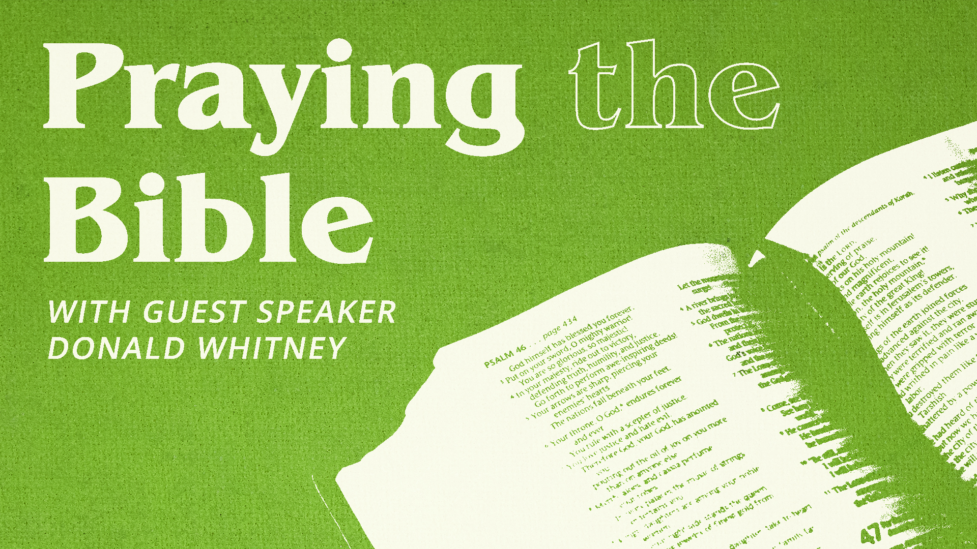
PRAYING THE BIBLE: Selected Texts

Many Christians feel defeated in their prayer lives. To pray even five-to-seven minutes seems like an eternity, and their minds wander much of that time. “I guess it’s me,” many conclude. “I’m just a second-rate Christian.” No, if you are indwelled by the Holy Spirit and generally seeking to live in obedience to God’s Word, then the problem likely isn’t you, but your method. Of course, there is no method that will enliven prayer for those who do not have the Holy Spirit. But those who are indwelled by the Spirit have received from God “the Spirit of His Son into our hearts, crying, ‘Abba! Father!’” (Rom. 8:15; Gal. 4:6). Those who have been given the Holy Spirit have by that Spirit a new Fatherward orientation, a new Heavenward orientation. In other words, those indwelled by the Holy Spirit really want to pray. And yet, while they believe in prayer and want to pray and can’t imagine ever totally abandoning prayer, when they do pray it’s frustrating. Their hearts are often cold, their minds can’t stay focused on prayer, and frankly, prayer is often boring. Thus many conclude, “I’m a second-rate Christian.”

- THE PROBLEM
Our problem is in prayer is . . . we say the same old things about the same old things.

Praying that way is often boring. When prayer is boring, we don’t feel like praying. And when we don’t’ feel like praying, it’s hard to concentrate in prayer and to pray for very long.

Our problem is not that we pray about the same old things. To pray about your . . .
- Family
- Future
- Finances
- Work or schoolwork
- Church or ministry
- And the “current crisis” is normal. If you’re going to pray about your life, these things are your life.

So our problem in prayer is not that we pray about the same old things, but that we say the same old things about the same old things. That’s boring. When prayer is boring we don’t feel like praying. And when we don’t feel like praying, it’s hard to pray for any length of time or with much consistency.

- THE SOLUTION
What’s the solution? Whatever it is, it must be fundamentally simple. For God has children of all ages, IQs, educational levels, etc. If He expects (and invites) all His children to pray, then consistent, meaningful prayer must be doable by all kinds of people. And if it were not possible for you—with all your Christian advantages (such as proximity to good churches, accessibility to Christian books, recordings, and other media, etc.)—to have a meaningful prayer life, then what of the tens of millions of Christians without these things?

Here’s the solution: when you pray, pray through a passage of Scripture, especially a Psalm.

- THE METHOD
Let the words of Scripture become the words of your prayers. For example, if you pray through Psalm 23, read “The Lord is my shepherd,” and thank Him for being your shepherd. Ask Him to shepherd your family that day, to guide, protect, and provide for them. Pray that He will make your family members His sheep; that they will look to Him as their shepherd. Ask Him to shepherd you through the decision you must make about your future. Pray for Him to bless the undershepherd at your church, shepherding him as he shepherds the church, etc. When nothing else comes to mind, go to the next line—“I shall not want”—and continue to pray.

Simply go through the passage, line-by-line, praying what you find in the text or what it brings to mind. If nothing comes to mind, or if you don’t understand the verse, go to the next. You might choose to linger long on one verse. Conversely, there may be only a handful of matters that prompt prayer as you go through many verses. Nothing says you have to pray over every verse.

Continue in this way until (1) you run out of time, or (2) you run out of Psalm.

One approach to choosing a Psalm to pray through is the “Psalms of the Day” approach. This divides the 150 Psalms into 5 Psalms for each of 30 days in a month. Take the day of month as your first Psalm. Then keep adding 30 to that number until you get 5 Psalms. So on the 15th of the month, your first Psalm is Psalm 15. To Psalm 15, add 30 to get the next one, Psalm 45. These would be followed by Psalm 75, then 105, and 135. (On the 31st, use Psalm 119.) Take 30 seconds to scan these five Psalms, then choose one to pray through. One advantage of this method is that gives you direction when it’s time to pray and defeats aimlessness.

The Psalms are the best place in Scripture from which to pray Scripture. This is because of the original purpose and usage of the Psalms. The Psalms were songs inspired by God for the purpose of being reflected in song back to God. Moreover, there’s a Psalm for every sigh of the heart. The entire range of human emotion is recorded in the 150 Psalms.

Perhaps the second-best place in Scripture from which to pray Scripture is the New Testament letters. These are so densely packed with truth that virtually every verse suggests something to pray about.

It is also edifying to pray through the narrative passages of Scripture. Unlike praying through the Psalms or New Testament letters, however, a different approach must often be used with the narrative passages. Instead of looking at each verse almost microscopically, in a narrative passage it’s usually easier to consider it paragraph-by-paragraph, looking for the “big ideas” of the story.

Once you actually experience praying through a passage of Scripture, you’ll likely be able to turn to any part of the Bible and pray through it. You won’t need these notes to remember how to do it the second time. Like riding a bicycle, you never forget.

By praying through a passage of Scripture, you’ll find yourself praying about most of “the same old things,” but in brand new ways. You’ll also find yourself praying about things you would never think to pray about.

Do not try to lead a group in praying through Scripture until most of the members of the group are familiar with praying through Scripture as individuals. When praying through Scripture with a group—whether the group is a family, a class, or a church prayer meeting—consider these suggestions:
- Good—Assign a verse to each person and have each pray through that particular verse.
- Better—Read the Psalm aloud (or have each read it silently), then ask each to pray based upon a verse that particularly impressed them.
- Best—Read the Psalm, then (you as the prayer leader) call out—one at a time as needed—the phrases or verses you think are the most conducive to prayer. Those willing to pray would pray as inclined to do so after one or more of the phrases or verses you call out.

The testimony of George Mueller.

The observation of Charles Spurgeon.

The examples of Jesus in Matthew 27:46 and Luke 23:46, and the church in Acts 4:23-26.

- THE CONCLUSION
Jesus prayed the Psalms. The early church prayed the Psalms. Great Christians like George Mueller prayed the Psalms. Why not you?

